
INTELLIGENT BUSINESS COMMUNICATIONS


Functional Requirements (FS) for
Local Number Portability – Interworking Function


NGIN 10.1
Part # 106-201-03-01035-01
© AGNITY GLOBAL INC. 2018 CONFIDENTIAL & PROPRIETARY

www.agnityglobal.com
0.2 | Draft | 06 Feb 2020
Version | Status | Date

Email: info@agnity.com

© AGNITY GLOBAL INC. 2020 CONFIDENTIAL & PROPRIETARY

Tel: +1-510-270-2669 | Fax: +1-510-353-1302
Legal
The AGNITY logo, ACONYX, and APTUS are trademarks of AGNITY™ Inc. All other trademarks are owned by their respective companies.

© 2007-2026 AGNITY™ Communication Inc.

All rights, including translation into other languages, reserved under the Universal Copyright Convention and other related instruments. Any use of this documentation and/or its associated software, including reproduction, modification, distribution, republication, transmission, re-transmission, or public showing, without the prior written permission of an authorized AGNITY representative, is prohibited.
This document and any software and programs mentioned in this document, whether delivered electronically or via other media, are the sole properties of AGNITY™ Communication Inc.

Document Revision History:
Ver. No. | Ver. Date | Prepared By | Reviewed By | Approved By | Affected Section & Summary of Change
0.1 | 31st Jan 2020 | Agnity Team |  |  | Initial Draft
0.2 | 6th Feb 2020 | Agnity Team | Agnity Team |  | Added section 3.3.3

Table of Contents
1 Introduction 5
1.1 Purpose 5
1.2 Scope 5
1.3 Intended Audience 5
1.4 Definitions, Acronyms, and Abbreviations 5
1.5 Requirements Matrix 5
1.6 References 6
2 Overall Description 7
2.1 Component Overview 7
2.2 System Details 7
2.2.1 Service Provisioning System (SPS) 7
2.2.2 Communication Application Server (CAS) 9
2.2.3 IN Connecter (INC) 10
2.2.4 Element Management System (EMS) 11
2.2.5 Oracle RAC DB 12
2.2.6 PSX for LNP 12
2.2.7 Radisys Media Server 12
2.2.8 Application Development Environment (ADE) 12
2.3 Application Triggering Criteria 12
3 LNP-IWF Features Details 13
3.1 Provisioning 13
3.2 CAS and PSX Heartbeat 13
3.3 Processing LNP Query 14
3.3.1 Successful LNP Lookup 15
3.3.2 Unsuccessful LNP Lookup 16
3.3.3 Application Specific Lookup 17
3.3.4 Error Scenario 21
3.4 Billing Parameters 22
4 Call Detail Record 23
4.1 Format of CDR 23
5 Open Items and Assumptions 25

Introduction

Purpose
This document captures the functional specification for Local Number Portability-Interworking Function (LNP-IWF). LNP core functionality is provided by Ribbon Communications Centralized Policy and Routing Service called PSX. LNP-IWF application provides interworking between SS7 network and LNP database.
LNP-IWF shall receive TCAP Query and shall perform LNP lookup over SIP to determine LRN. PSX details has been kept out-of-scope of this documents.

Scope
This document defines the functional specifications of the changes requested for LNP-IWF.

Intended Audience
This document is intended for the employees and customers of AGNITY.

Definitions, Acronyms, and Abbreviations
Terms | Description
CAS | Communication Application Server
SPS | Service Application System
wEMS | Web-based Element Management System
LNP | Local Number Portability

Requirements Matrix

Requirement | Document Section

References
Reference to FCD and customer documents

Overall Description

Component Overview
Agnity NGIN 10.1 solution is a multi service, next generation, converged service control platform as well as an application server, providing flexible, high performance communications services.

Below diagram provides high level overview of components along with connectivity, required for the solution.

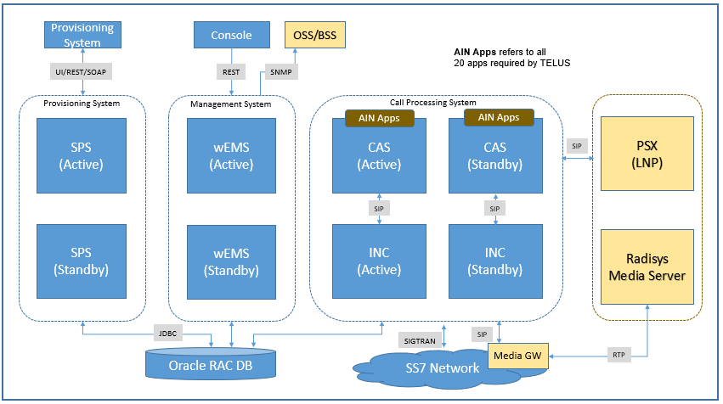
Figure 1: Logical View of OrionLite Deployment

System Details
The NGIN 10.1 system supporting the applications has the following modules

Service Provisioning System (SPS)
This module is responsible for providing API and GUI interfaces for provisioning of any data which is required for the AIN applications.
On a high level the same backend functions are called by both REST API with JSON payload and GUI.
The REST APIs can be used for integration of SPS with customer provisioning system. HTTP or HTTPS can be configured and used for accessing the GUI portal.
The main functions delivered by the SPS are listed below:

- Service Management – including service deployment, configuration

- Subscriber Provisioning – enabling service provider administration or delegated subscriber level administration of subscription data for a given service subscription.

- Data Versioning – enabling roll forward and rollback of provisioned data.
- User interface – providing both a Web-based graphical user interface (GUI) and a telephonic user interface (TUI) for provisioning data for service subscriptions by authorized service provider administrator and/or enterprise administrator and/or end users.
- OSS Interface – providing interfaces to a carrier’s existing OSS systems via REST.
- Golden Gate is used for replicating data across sites.
- System maintains one previous version of the data in the SPS
- System will automatically deletes the older previous versions records
- REST API invocation will be captured in Audit Log, this includes
- Login Attempts
- Any PUT/POST or DELETE operation
- GET requests won’t be part of Audit Log
- Support ReadOnly and ReadWrite policy

SPS is responsible for provisioning of data for the services deployed on the CAS platform cluster(s) and related network elements.

Two Stage Provisioning
SPS in case of two stage provisioning changes will be carried out in the SPS database first and once the changes are completed, they will be activated in both SPS and CAS DB.

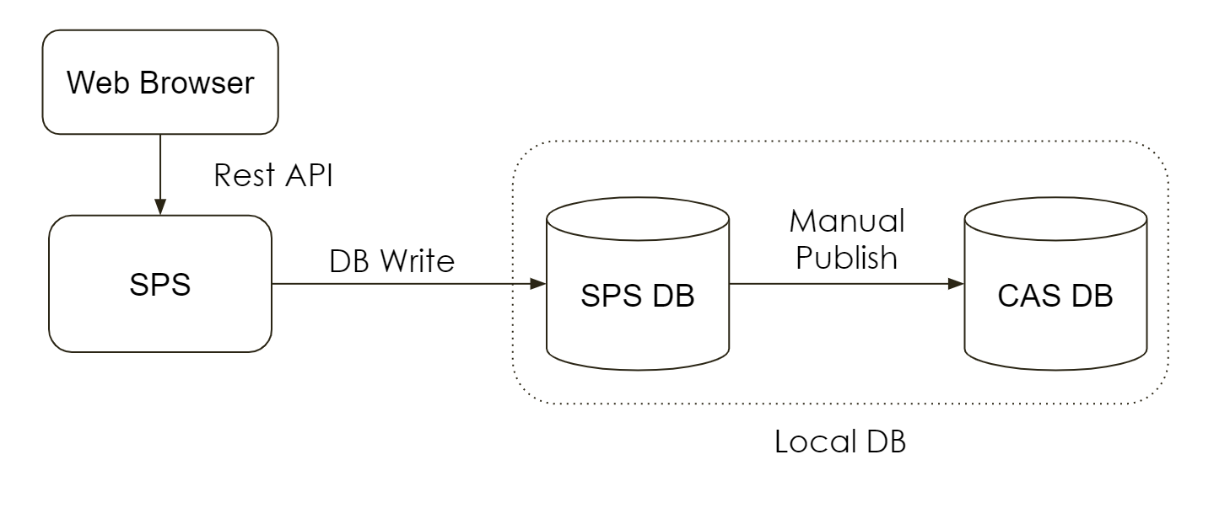

Implicit Unit of Work (UOW)
UOW is the unit of work. It is basically used to aggregate the changes carried out by the user as one unit and this unit will be published and activated in the database.

Implicit UOW specify creation of UOW on the fly. User will not be provided with API to create or select UOW. There can be at max one UOW per user.

All the RestAPI response provide back the client the UOW if one active for the user. Having an active UOW is an indication there are uncommitted changes carried by the user present in the SPS DB.

Bulk Provisioning
Depending on the customer needs, a separate Application will be created to consume the Custom CSV provided by the client and call multiple composite API for provisioning.

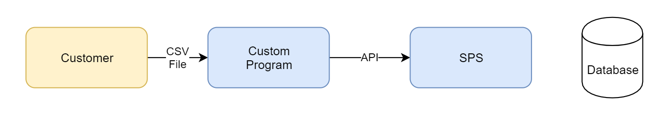

Communication Application Server (CAS)
The Communication Application Server (CAS), is java based, an enhanced service platform designed for VoIP networks. It leverages the SIP Servlet API 1.1 JSR 289 to provide an extensible, standards-based application interface for building and deploying applications.
CAS provides support for converged networks spanning IP, TDM, and 3G infrastructures. With native support for HTTP, SMPP, Rf, Ro, and sh signaling, the CAS can support a full suite of consumer and business applications independent of the underlying network.
CAS supports JAIN TCAP API 1.0 which allows developing SS7 application as standalone application or converged application (SS7, SIP and/or HTTP can co-exist). However, CAS MUST be installed with IN Connector (INC) for any SS7 application to inter-work with SS7 network.

The diagram below shows the CAS Architecture:
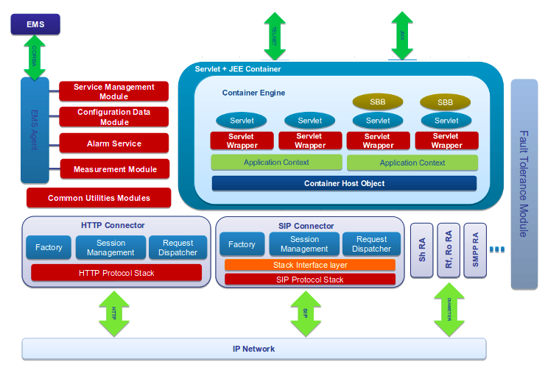
Figure 2: CAS Architecture

IN Connecter (INC)
IN Connector (INC) provides connectivity to the SS7 network. INC, on southbound interface, connects to SS7 network elements (STP or SSP or ISTP) over E1/T1 or SIGTRAN (SS7 over IP) and on northbound interface, connects to CAS over SIP.
It encapsulates TCAP payload in SIP message and sends to CAS. CAS implements different SS7 applications handler like AIN, INAP, CAMEL etc and based on TCAP payload it handles it accordingly.
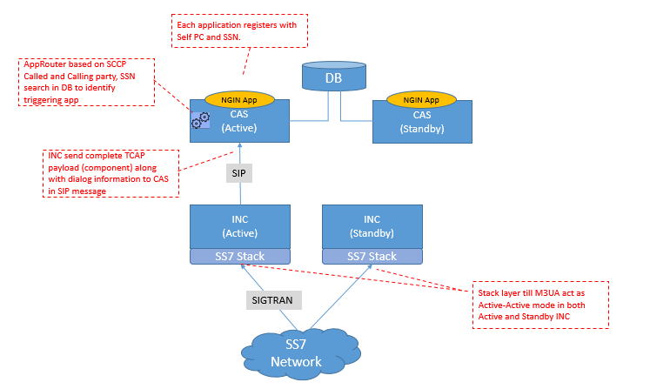
Figure 3: INC Deployment

Element Management System (EMS)
The broad-level function of the EMS is to manage and monitor different ACONYX components such as CAS, Provisioning System like SMS and optionally third-party components like Oracle Databases, IVR’s etc. Components that are managed by EMS are also referred to as managed components. This interface between Network Management level and EMS is referred to as southbound interface.
EMS provides a graphical interface called EMS Console. Third party OSS can also access EMS through its northbound interface over SNMP. This interface between wEMS and Network Element level is referred to as northbound interface.
High Level functionalities of EMS are as below:
  - Display graphical positioning of components per site
  - Monitoring the status of the network clusters, systems, subsystems, network resources (Oracle databases, IVR’s etc.) and optionally third-party components
  - Maintains the hardware and software inventory of all the hosts, Network interface cards and Managed products and services
  - Receive and processes alarms from the managed components
  - Receive and processes traps from registered third Party components
  - Forwards Alarms as traps to configured third Party destinations
  - Collect performance data from managed components, hosts etc.
  - Authenticate and authorize EMS users to perform above functions before granting access

Oracle RAC DB
Oracle RAC DB is used by wEMS, CAS and SPS. SPS stored provisioning data, whereas wEMS used DB for storing alarms, counters and other management information. CAS reads provisioning data from Oracle required for call processing.
Golden Gate is used for data replication across geo-redundant sites.

PSX for LNP
Ribbon PSX shall be used by AIN application to perform LNP lookup. This communication shall happen over SIP protocol. CAS shall send the lookup number as Calling and Called party in outgoing SIP INVITE and PSX shall respond back with 300 Multiple Choice as response with LRN in contact header.

Radisys Media Server
Radisys Media Server shall be used by the application having requirement for IVR interaction. Detailed approach for media server interaction is defined in section below.

Application Development Environment (ADE)
ADE provides graphical interface for creating an application. LNP-IWF shall be created through ADE.

Application Triggering Criteria
System uses AppRouter module, in-built in CAS, which based on certain parameters decides the application to be triggered. This includes
- SCCP Called Party
- SCCP Calling Party
- SSN
- Triggering Criteria
All traffic to LNP shall be coming on SSN 254, which will be unique among all the applications deployed on CAS. Hence, LNP shall be triggered with SSN 254. There shall be no subscriber database with CAS.

LNP-IWF Features Details
LNP-IWF application shall perform interworking between S7 switches and PSX. There shall be 2 PSX server per site. CAS shall query PSX server in round-robin fashion.
The TriggerCriteriaType parameter shall come as - localNumberPortability (37)

Provisioning
No subscriber provisioning shall be required for LNP-IWF application in system. PSX shall expose provisioning interface which shall be used for provisioning.

CAS and PSX Heartbeat
- There shall be 2 PSX instances at each site.
- CAS shall always perform query with local instances in round-robin fashion
- CAS shall always perform heartbeat with PSX to perform health check. For that CAS shall send SIP OPTIONS after every 2 seconds. In case PSX doesn’t responds to 2 subsequent OPTION, PSX shall be considered down. In which case CAS will keep sending to other PSX instance till first PSX responds back with response to SIP OPTIONS
- It is assumed that each PSX instance on all sites shall have same data at any instance of time.
- CAS shall configure IP and port information for each PSX.
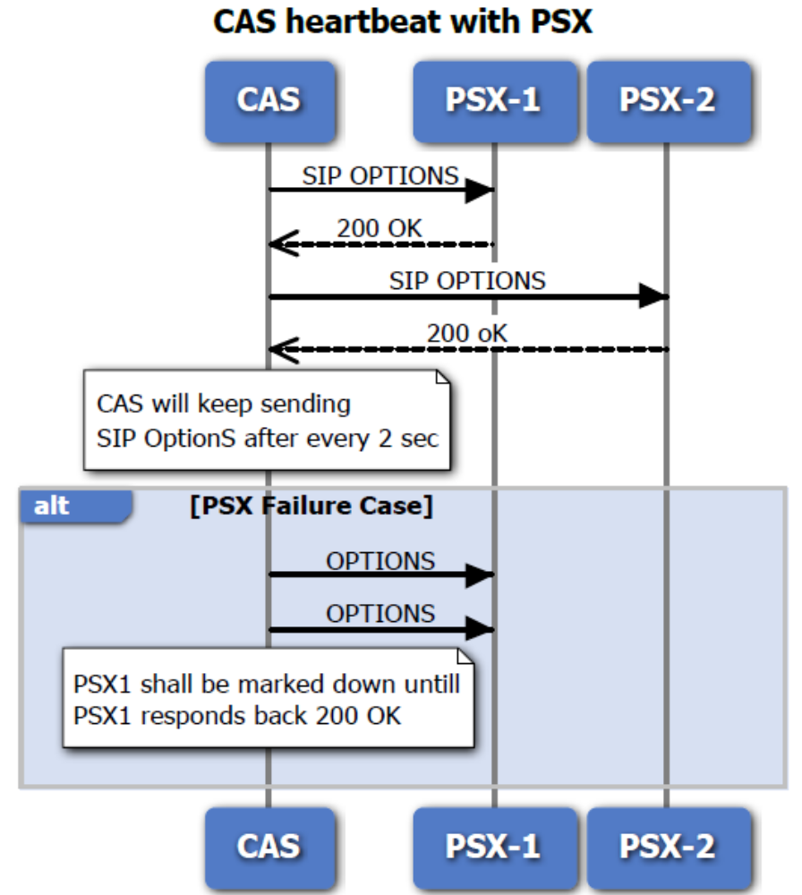
Figure 4: CAS and PSX heartbeat scenario

Processing LNP Query
This section captures the handling for LNP query received by LNP-IWF application on CAS. There could be two cases
- LNP lookup is successful and PSX returns LRN
- LNP Lookup is not successful and PSX doesn’t return LRN
Routing for each is defined in section below

Successful LNP Lookup
- InfoAnalyze is received from the switch
- Application shall extract following parameters from incoming InfoAnalyze
  - Calling Party ID
  - Called Party ID
- It is mandatory to have Called Party ID as field in request for LNP Query.
- Application shall create SIP INVITE for PSX which shall be From header having Calling Party ID and RURI as well To header as Called Party ID

INVITE sip:5104567891@PSX_IP:PSX_Port SIP/2.0

- PSX based on number received in RURI, shall perform LNP lookup and return LRN if number is ported, in 300 Multiple Choices response as shown below

Contact: <sip:5104567891@CAS_IP:CAS_PORT;rn=4109923923>

- Application shall send the response as AnalyzeRoute with
  - Calling Party ID – same as received
  - Called Party ID – rn received in 300 Multiple Choice
- For ported DNs, the LNP SCP will be expected to return a CalledPartyID that is not equal to the Dialed number. This CalledPartyID will be viewed by the switch as an LRN and will be used to route to the recipient switch.

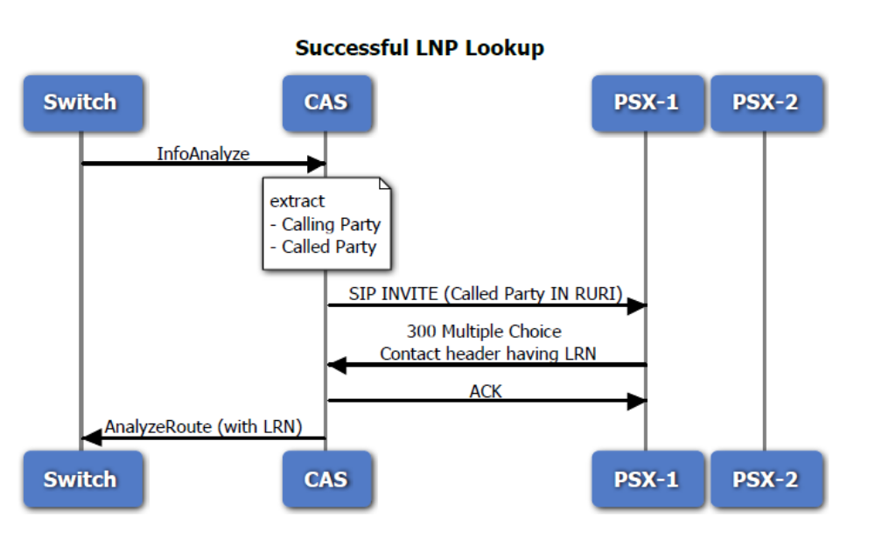
Figure 5: Successful LNP Lookup flow

Unsuccessful LNP Lookup

- InfoAnalyze is received from the switch
- Application shall extract following parameters from incoming InfoAnalyze
  - Calling Party ID
  - Called Party ID
- It is mandatory to have Called Party ID as field in request for LNP Query.
- Application shall create SIP INVITE for PSX which shall be From header having Calling Party ID and RURI as well To header as Called Party ID

INVITE sip:5104567891@PSX_IP:PSX_Port SIP/2.0

- PSX based on number received in RURI, shall perform lookup. In case not found, PSX shall 300 Multiple Choices without rn as shown below.

Contact: <sip:5104567891@CAS_IP:CAS_PORT>

- Application shall send the response as AnalyzeRoute with
  - Calling Party ID – same as received
  - Called Party ID – same as received
- For non-ported DNs, the CalledPartyID in the LNP SCP response will be equal to the dialed number and the switch will route the call normally based on the dialed number, and no GAP Ported Dialed Number will be populated by the switch.
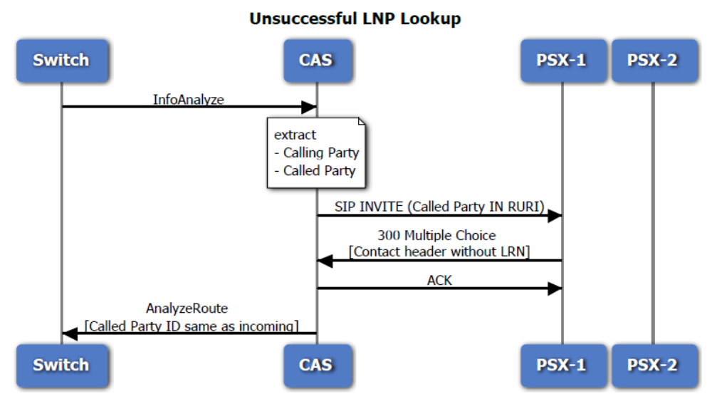
Figure 6: Unsuccessful LNP lookup call flow

Application Specific Lookup
LNP DB shall maintain DPC-SSN corresponding to different application like CLASS, LIDB, CNAM and ISVM. CAS shall implement different services, and based on request it receive, it shall request LNP to provide LRN and associated DPC-SSN for the request service.

Sample LNP table is shown below. For each LRN there are separate DPC-SSN for different applications.

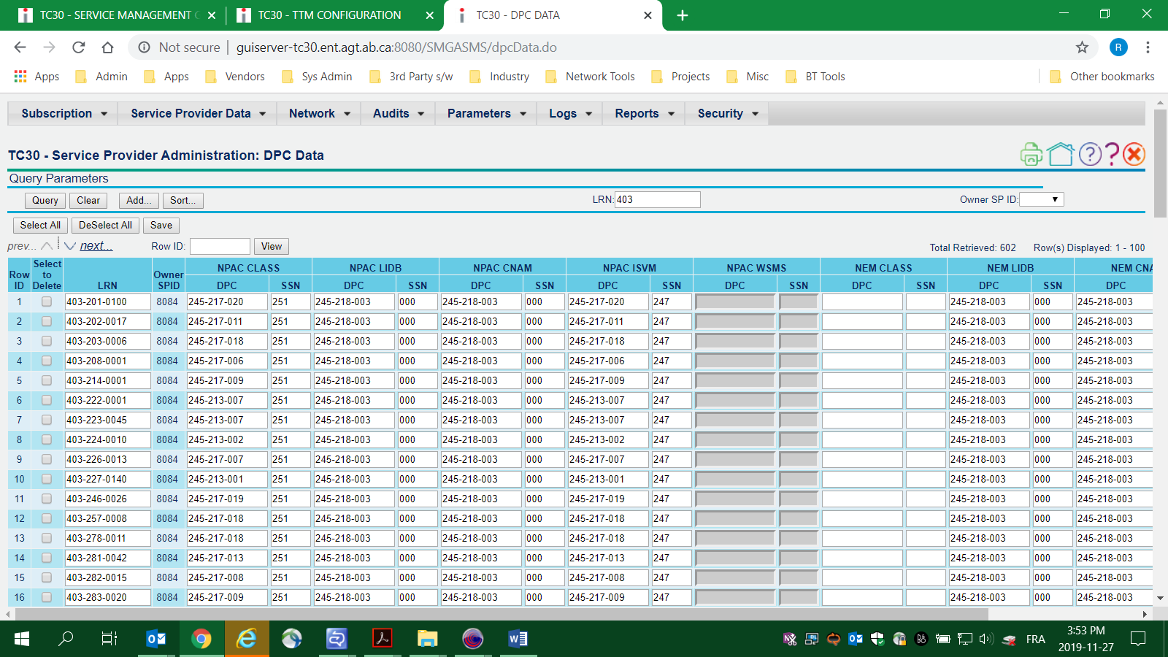

Following table suggest the content of SIP request to PSX and expected response.

Service Type | Request URI to PSX | Expected Response from PSX | Description
LNP – successful | INVITE sip:5104567891@PSX_IP:PSX_Port SIP/2.0 | Contact: <sip:5104567891@CAS_IP:CAS_PORT;rn=4109923923> | LNP Query
LNP – Unsuccessful | INVITE sip:5104567891@PSX_IP:PSX_Port SIP/2.0 | Contact: <sip:5104567891@CAS_IP:CAS_PORT> | Number is not ported. PSX still sends 300 MC without lrn
LNP for CNAM | INVITE sip:5104567891@PSX_IP:PSX_Port;QTYPE=CNAM SIP/2.0 | Contact: <sip:5104567891@CAS_IP:CAS_PORT;rn=4109923923;dpc=254-22-22;ssn=251> | QTYPE=CNAM in RURI  300 MC contains contact with rn, dpc and ssn corresponding to CNAM
LNP for CNAM – unsuccessful | INVITE sip:5104567891@PSX_IP:PSX_Port;QTYPE=CNAM SIP/2.0 | [a]  Contact: <sip:5104567891@CAS_IP:CAS_PORT;rn=4109923923>  [b]  Contact: <sip:5104567891@CAS_IP:CAS_PORT> | [a] DPC/SSN not defined. Only lrn returned.  [b] lrn not defined.
LNP for LIDB | INVITE sip:5104567891@PSX_IP:PSX_Port;QTYPE=LIDB SIP/2.0 | Contact: <sip:5104567891@CAS_IP:CAS_PORT; rn=4109923923;dpc=254-22-22;ssn=251> | QTYPE=LIDB in RURI  300 MC contains contact with rn, dpc and ssn corresponding to LIDB
LNP for LIDB – unsuccessful | INVITE sip:5104567891@PSX_IP:PSX_Port;QTYPE=LIDB SIP/2.0 | [a]  Contact: <sip:5104567891@CAS_IP:CAS_PORT;rn=4109923923>  [b]  Contact: <sip:5104567891@CAS_IP:CAS_PORT> | [a] DPC/SSN not defined. Only lrn returned.  [b] lrn not found.
LNP for CLASS | INVITE sip:5104567891@PSX_IP:PSX_Port;QTYPE=CLASS SIP/2.0 | Contact: <sip:5104567891@CAS_IP:CAS_PORT; rn=4109923923;dpc=254-22-22;ssn=251> | QTYPE=CLASS in RURI  300 MC contains contact with rn, dpc and ssn corresponding to CLASS
LNP for CLASS – unsuccessful | INVITE sip:5104567891@PSX_IP:PSX_Port;QTYPE=CLASS SIP/2.0 | [a]  Contact: <sip:5104567891@CAS_IP:CAS_PORT;rn=4109923923>  [b]  Contact: <sip:5104567891@CAS_IP:CAS_PORT> | [a] DPC/SSN not defined. Only lrn returned.  [b] lrn not defined.
LNP for ISVM | INVITE sip:5104567891@PSX_IP:PSX_Port;QTYPE=ISVM SIP/2.0 | Contact: <sip:5104567891@CAS_IP:CAS_PORT; rn=4109923923;dpc=254-22-22;ssn=251> | QTYPE=ISVM in RURI  300 MC contains contact with rn, dpc and ssn corresponding to ISVM
LNP for ISM – unsuccessful | INVITE sip:5104567891@PSX_IP:PSX_Port;QTYPE=ISVM SIP/2.0 | [a]  Contact: <sip:5104567891@CAS_IP:CAS_PORT;rn=4109923923>  [b]  Contact: <sip:5104567891@CAS_IP:CAS_PORT> | [a] DPC/SSN not defined. Only lrn returned.  [b] lrn not defined.

CNAM Query
- TCAP Query (as per GR-1188) is received from the switch
- Application shall extract following parameters from incoming query
  - Calling Directory Number
- Application checks for CNAM for incoming directory number. If found that it shall be returned as response.
- If not found, application shall create SIP INVITE for PSX which shall have both From and To header as well as RURI containing Calling Directory Number.
  - SIP INVITE shall contain attribute QTYPE=CNAM, which shall be used by PSX to identify the service for which DPC-SSN has to be fetched.

INVITE sip:5104567891@PSX_IP:PSX_Port;QTYPE=CNAM SIP/2.0

- PSX based on number received in RURI, shall perform LNP lookup and return LRN and associated DPC and SSN if number is ported, in 300 Multiple Choices response as shown below

Contact: <sip:5104567891@CAS_IP:CAS_PORT;rn=4109923923;dpc=254-22-22;ssn=251>

- Application shall dip into local DB table corresponding to returned lrn to fetch DPC and SSN for CNAM. Local DB table shall have overridden DPC-SSN values. If not found then DPC-SSN value returned by PSX shall be used as GTT. In case local DB contain DPC-SSN information then it shall be used as GTT.

LIDB Query (BNS)
- TCAP Query (as per GR-1149) is received from the switch
- Application shall extract following parameters from incoming query
  - Calling Number
  - Called Number
- Application checks for BNS for incoming number. If found that it shall be returned as response.
- If not found, application shall create SIP INVITE for PSX which shall have both From as calling and To and RURI as Called Number.
  - SIP INVITE shall contain attribute QTYPE=LIDB, which shall be used by PSX to identify the service for which DPC-SSN has to be fetched.

INVITE sip:5104567891@PSX_IP:PSX_Port;QTYPE=LIDB SIP/2.0

- PSX based on number received in RURI, shall perform LNP lookup and return LRN and associated DPC and SSN if number is ported, in 300 Multiple Choices response as shown below

Contact: <sip:5104567891@CAS_IP:CAS_PORT;rn=4109923923;dpc=254-22-22;ssn=251>

- Application shall dip into local DB table corresponding to returned lrn to fetch DPC and SSN for LIDB. Local DB table shall have overridden DPC-SSN values. If not found then DPC-SSN value returned by PSX shall be used as GTT. In case local DB contain DPC-SSN information then it shall be used as GTT.

Message Relay Service
- TCAP Query (as per GR-1149) is received from the switch
- Application shall extract following parameters from incoming query
  - Calling Number
  - Called Number
- Application checks for BNS for incoming number. If found that it shall be returned as response.
- If not found, application shall create SIP INVITE for PSX which shall have both From as calling and To and RURI as Called Number.
  - SIP INVITE shall contain attribute QTYPE=CLASS, which shall be used by PSX to identify the service for which DPC-SSN has to be fetched.

INVITE sip:5104567891@PSX_IP:PSX_Port;QTYPE=CLASS SIP/2.0

- PSX based on number received in RURI, shall perform LNP lookup and return LRN and associated DPC and SSN if number is ported, in 300 Multiple Choices response as shown below

Contact: <sip:5104567891@CAS_IP:CAS_PORT;rn=4109923923;dpc=254-22-22;ssn=251>

- Application shall dip into local DB table corresponding to returned lrn to fetch DPC and SSN for CLASS. Local DB table shall have overridden DPC-SSN values. If not found then DPC-SSN value returned by PSX shall be used as GTT. In case local DB contain DPC-SSN information then it shall be used as GTT.

Error Scenario

PSX Not available
- CAS maintains the heartbeat of PSX. Assuming both PSX are down. Application shall send AnalyzeRoute

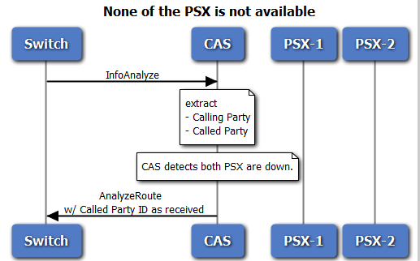
Figure 7: PSX unavailability handling

Billing Parameters
No AMA parameter shall be sent in response. However, CDR shall be created locally.

Call Detail Record
CAS provides support for the services in writing the Call Detail Records at the runtime using the CDR interface. Currently CDR support in CAS includes the following:

- CAS writes the CDR to files as a comma-delimited list of values in the pre-defined locations.
- CAS provides high-availability of CDRs by writing them to two locations simultaneously.
- The CAS also supports turning OFF CDR writing to either one or both of the CDR locations. CDR locations can be configured during hardware staging period.
- CAS allows the user to define format for writing the CDRs for an application.
- CAS provides configuration parameter for configuring the maximum number of CDRs to be written to a file. It provides configuration parameter for configuring the maximum time after which the CDR files are rolled over.
- CDR files are archived periodically through Housekeeping scripts. User can define retention period as per the requirement.
- CDRs can be fed o reporting system in order to generate traffic reports.
- CDR files format contains following fields
<CDR File Prefix>_<Thread_Id>P|S<Running Number>.<CDR Extension>

Where:
CDR File Prefix: This can be configured in CAS property file. Name may contain cluster/site information.
Thread_Id: For optimized performance, user may define parallel number of worker threads writing CDRs.
P|S: P stands for Primary CDR and S for secondary CDR
Running Number: Monotonically increasing number with maximum as integer 2^32.
CDR Extension: CDR file will end with this extension.

Sample CDR Files, with CAS as prefix, CDR thread configured as 3, and CDR Extension as ACT
- CAS_0P1.ACT
- CAS_1P1.ACT
- CAS_2P1.ACT
- CAS_0P2.ACT
- CAS_1P2.ACT
- CAS_2P2.ACT and so on

Format of CDR
Note: CDR Fields will get enhanced based on new features development requirements.

Field No | Field Name | Field Description and Possible values
1 | Identifier | SRVED
2 | Version ID | Version ID of the CDR. Service ID will be written to this field.
3 | Data record ID | 0: single CDR.
4 | Service ID | Identifies LNP IWF i.e. 100
5 | Originating Call ID | Dialogue ID for call
6 | Originating Point Code | Point code of originator
7 | SSN | SSN received
8 | Calling Party Number | Calling party received in incoming message
9 | Dialed Number | Called Party ID received in incoming message
10 | LNP Lookup Status | 1 – Successful  0 – Unsuccessful
11 | LRN | LRN
12 | Call Answer Time | Call answer time shall be recorded on receiving oAnswer from switch
13 | Call Disconnect Time | Call end when receiving Close or Termination Notification from network
14 | Triggering Criteria | Triggering Criteria
15 | Cause Code | 0-UNKNOWN_CAUSE_CODE;  200 – SUCCESS  101-ABORT_EVENT_RECEIVED;  102-PSX NOT AVAILABLE

Open Items and Assumptions

